Project Report: Driver Report Card

# Introduction:

Road accidents are the biggest problem for our society. And road accidents are difficult to predict but through some data calculation and analysis, we can find the probability for these accidents.

First of all, we will collect some data about the drivers as an input, then we will define the parameters to determine the probability then we will calculate different probabilities for different conditions. Like we will check either driver is drunk or not, the number of passengers, driving style, etc. After collecting this data we will do some processing by considering all the factors and estimating the best possible situation results. We will rewrite all probabilities and will display our results. Here our task will end.

# Objectives:

These objectives were set for this project:

* To correctly calculate the chances of accident of each factor
* Calculate the grade of driving habits of driver
* Calculate the cumulative grade points

# Procedure:

The algorithm of this whole task is mainly divided into three main steps. Here all three steps are discussed as below.

First thing is that how we can find the probability of speed of a potential driver while driving a vehicle. For this purpose we will use a formula written below:

S= {A, B}

The probability of data point A will be

$$Pa = A/A+B =m :n$$

So, $m :n$

Now the second point is that there will be many factors enhancing the probability of accidents. Like age, gender, driving style, day and time, physical and mental health. So these factors could increase or decrease the possibility of over speeding and accidents. So, to know the effect of these factors we can multiply a factor “ $x$” with $m:n$

For now data points for which “more times likely x” is given

So,

$$Pa = x(m):n$$

$$Pa=(x*m) / ( x.m +n )$$

This formula will give us the factored probability of over speeding and accidents depends on the factor we have considered and applied. One or more factors can be applied at the same time.

**For Example,** A teenage boy with a very rough driving style is depressed due to some reasons and is drunk as well and he is driving a car at a midnight will have a much higher possibility of over speeding and accidents than a mature guy driving carefully.

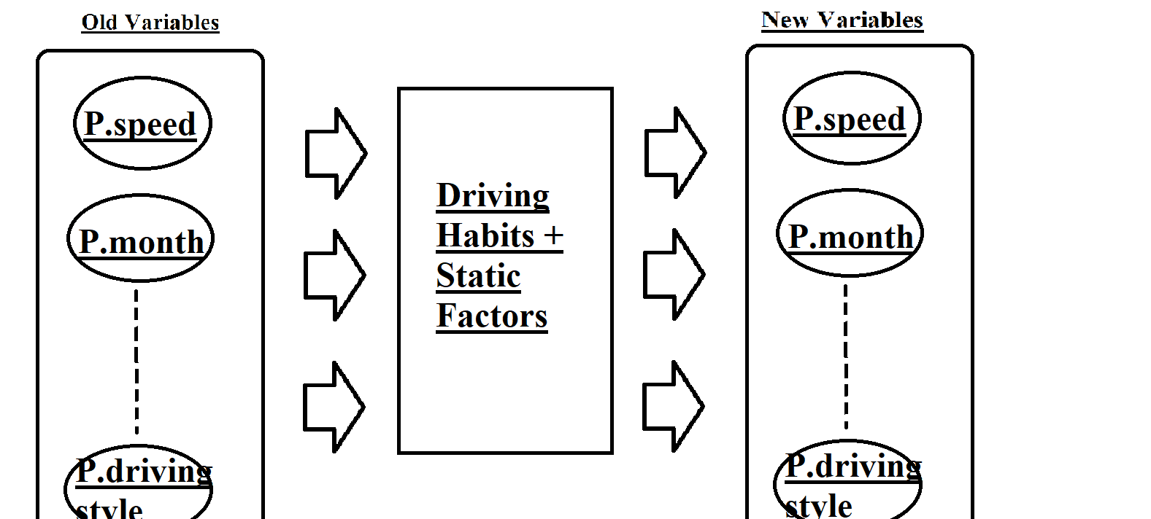

# Results:

As result, we will show the worst and best scenarios depending upon the driver’s conditions and factors affecting the driving of a person.

## Best Case Scenario:

### Input Screenshots:

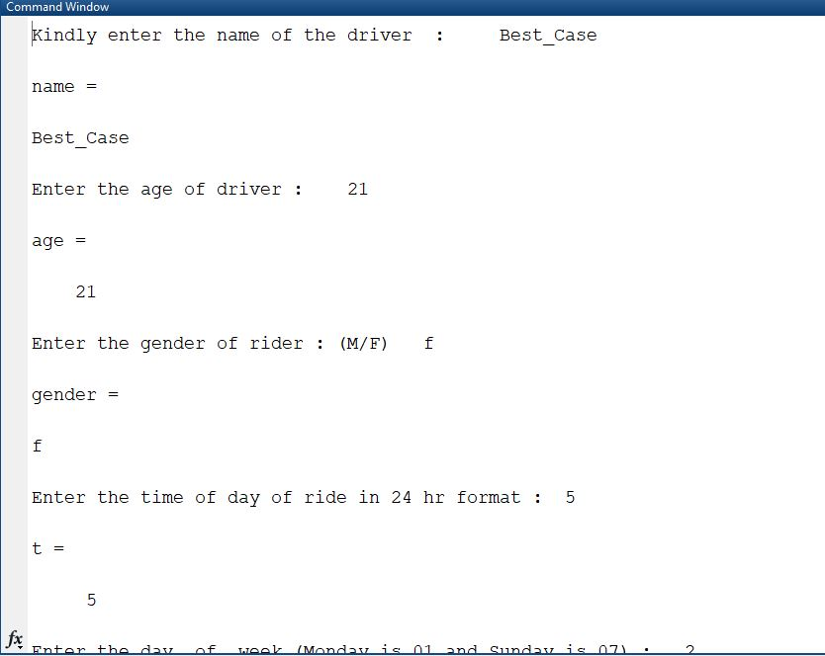

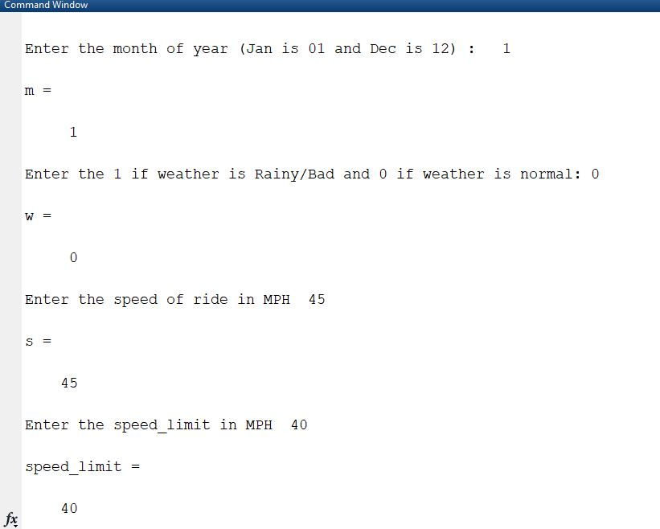

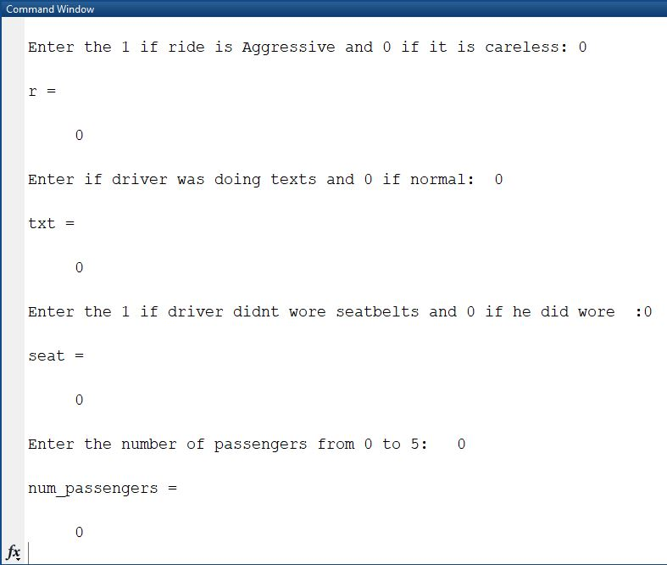

### Output Screenshot:

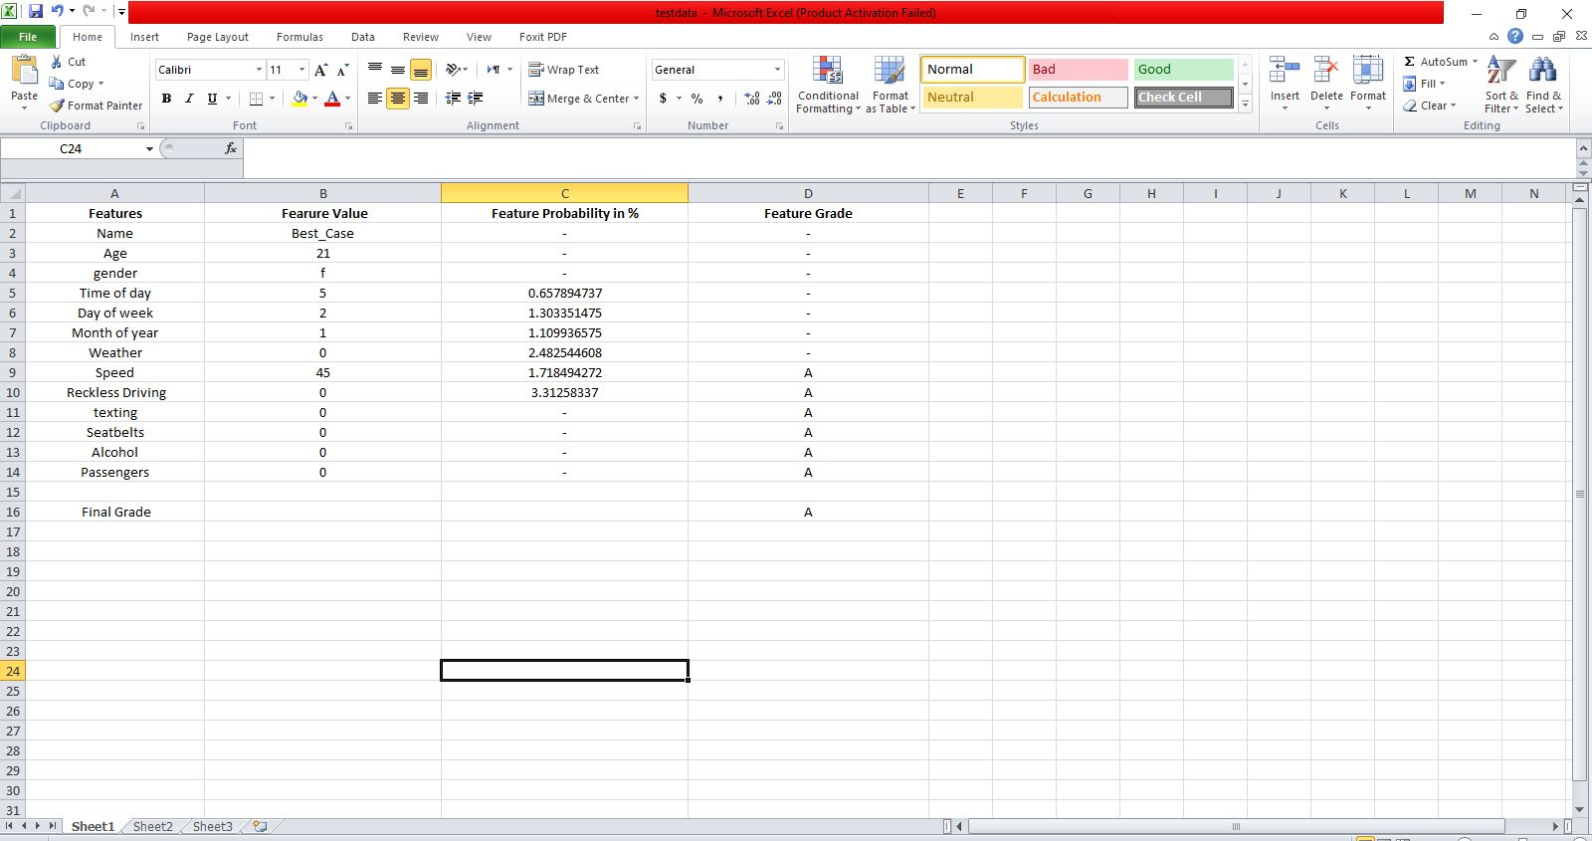

## Worst Case Scenario:

### Input Screenshot:

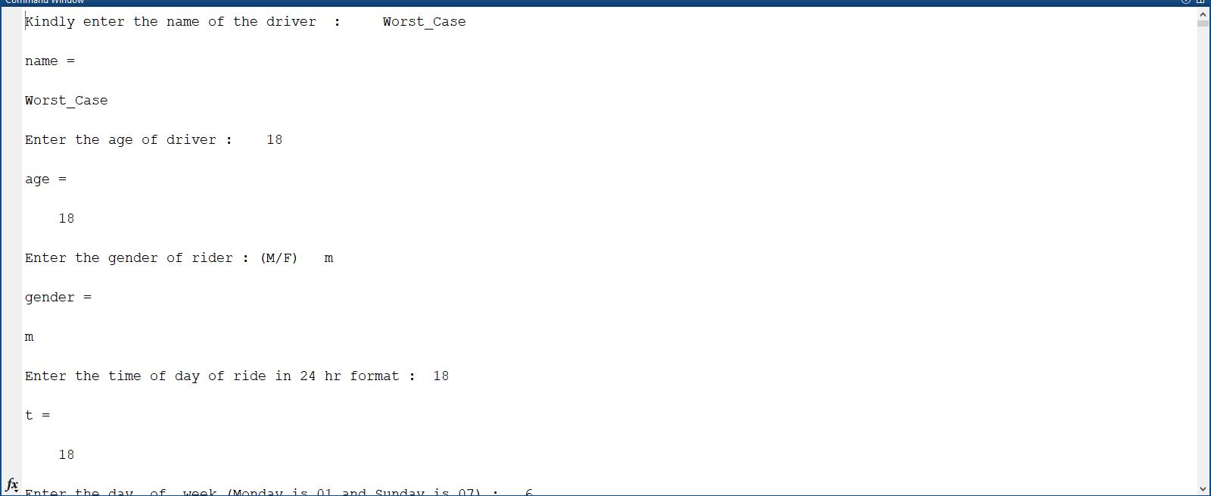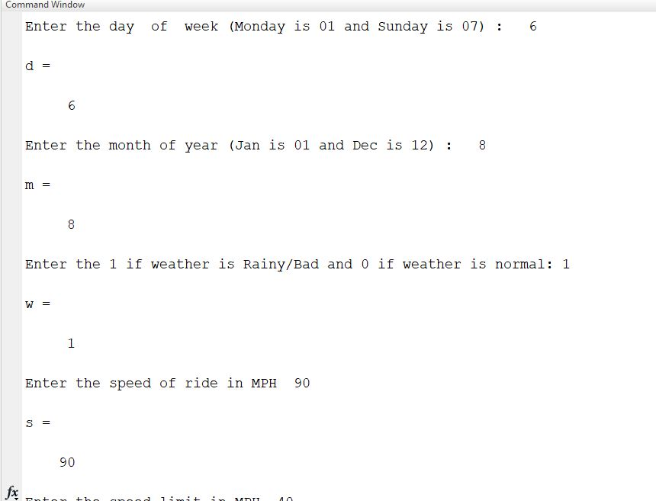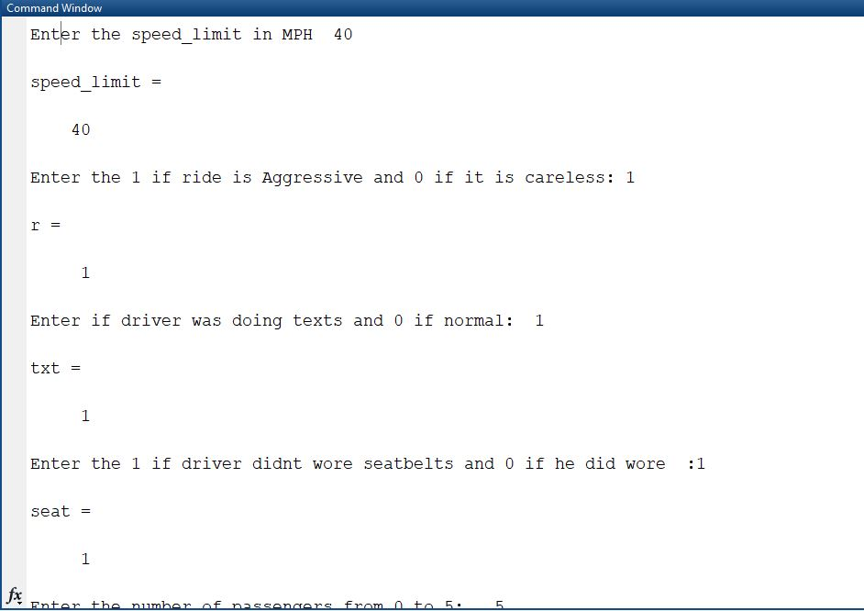

### Output Screenshot:

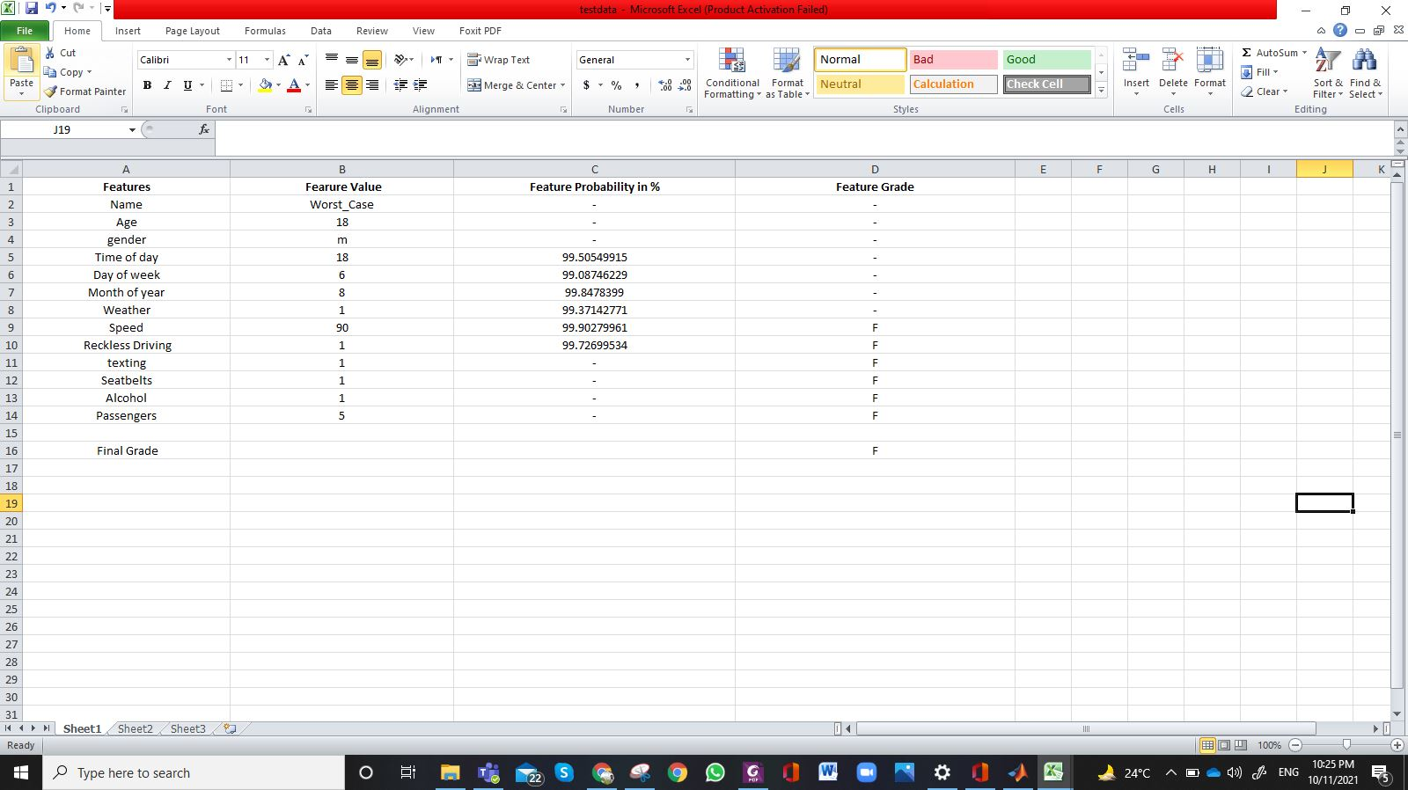

# Conclusion:

We can provide the best possibility for a road accident by considering some factors related to drivers and their driving styles. We can predict how time (day and night), health (physical and mental), driving style, drinking, age, use of mobile phones could increase and decrease the probability of an accident. This will help us a lot to predict the accidents and to control them by making suitable strategies to overcome these problems caused due to driver’s behavior.